PROJECT REPORT
REAL-TIME INDIAN SIGN LANGUAGE
RECOGNITION SYSTEM
A Dual-Branch Deep Learning Approach for Static Alphabet and Dynamic Sign Recognition
Submitted by
K. Sai Sharat
Registration Number: 24BCE7733
Department of Computer Science and Engineering
Institution: ______________________________
Academic Year: 2026–2027
Submitted in partial fulfilment of the requirements for the project

ABSTRACT
Indian Sign Language (ISL) is a visual language in which meaning is conveyed through hand configuration, orientation, location, motion, and other non-manual cues. Communication barriers arise when signers interact with people who do not understand ISL. This project report documents a real-time, camera-based recognition system that identifies static alphabet gestures and dynamic word-level gestures, then displays the predicted sign label as text. The system is organized as two complementary branches: a MobileNetV2-based convolutional neural network (CNN) for single-frame alphabet recognition, and a spatiotemporal pathway that samples a sequence of 16 frames, extracts visual features, and models temporal dependencies using a bidirectional recurrent network such as Bi-LSTM or GRU.
The supplied dataset/evaluation report records 98.38% training accuracy, 80.46% validation accuracy, and 86.38% held-out test accuracy for the static MobileNetV2 branch, evaluated on 5,198 test images. It documents 25,238 clean alphabet images after duplicate removal, 23,156 hand-centred crops, and 3,600 dynamic videos across 60 classes.
The report follows the requested project-report organization: introduction, recent literature review, proposed methodology, dataset description, results, and conclusion. Original diagrams and charts are included. Research-paper figures are discussed and cited rather than copied without context. The work is a sign-to-text classifier for a predefined vocabulary; speech synthesis and unrestricted natural-language translation are outside the current scope.
Keywords: Indian Sign Language, deep learning, CNN, MobileNetV2, Bi-LSTM, GRU, temporal modelling, computer vision, static gesture, dynamic gesture.

REPORT STRUCTURE AND EVALUATION NOTES
The requested page targets are treated as minimum content goals: Introduction (at least 7 pages), Literature Review (at least 4 pages), Proposed Methodology (at least 9 pages), Dataset Description (at least 2 pages), Results (at least 4 pages), and Conclusion (at least 3 pages). The report uses chapter headings and numbered subsections, tables, diagrams, plots, and references in a conventional academic-project format.
Important scope correction: the attached conference template concerns coffee-leaf semantic segmentation. Its instruction to show segmented output images for four or five segmentation models does not match sign-language classification. In this ISL report, the relevant equivalent would be the same input frame paired with the predicted class from each tested recognition model. The available project materials do not contain the actual same-frame outputs from four or five trained models, so no such results are fabricated. A comparative model table is included with explicit separation between the model implemented in this project, architectures discussed in literature, and models not evaluated on the supplied test set.
Metric provenance is preserved using the latest supplied Dataset and Evaluation Report. The static MobileNetV2 global test result is 86.38% over 5,198 test images. The dynamic report separately lists 92.00% for an integration mock test and 76.53% for a full-matrix evaluation pending review; these are not merged into one score. Dataset counts and augmentation status are updated from the supplied report.

TABLE OF CONTENTS
1. INTRODUCTION
1.1 Background and context
1.2 Problem statement
1.3 Motivation and significance
1.4 Deep neural networks for sign recognition
1.5 Static versus dynamic signs
1.6 Aim, objectives, and scope
1.7 Contributions and report organization
2. LITERATURE REVIEW / RELATED WORK
2.1 Search and selection scope
2.2 Vision-based ISL recognition
2.3 CNNs and transfer learning
2.4 Temporal modelling for dynamic signs
2.5 Transformers, pose, and graph methods
2.6 Comparative synthesis and research gap
3. PROPOSED METHODOLOGY
3.1 System overview
3.2 Acquisition and preprocessing
3.3 Static branch
3.4 Dynamic branch
3.5 Temporal sampling and recurrent modelling
3.6 Training and regularization
3.7 Inference and text output
3.8 Complexity, robustness, and reproducibility
4. DATASET DESCRIPTION
4.1 Static dataset
4.2 Dynamic dataset
4.3 Splitting and leakage prevention
4.4 Augmentation and limitations
5. RESULTS
5.1 Static evaluation
5.2 Dynamic evaluation status
5.3 Metric interpretation
5.4 Model comparison
5.5 Error analysis and limitations
6. CONCLUSION
6.1 Summary
6.2 Contributions
6.3 Limitations
6.4 Future work
REFERENCES

1. INTRODUCTION - CONTEXT AND MOTIVATION
Human communication relies on shared language, but communication between sign-language users and people unfamiliar with signing can be difficult in classrooms, public services, healthcare, transport, workplaces, and everyday interactions. Indian Sign Language (ISL) is a natural language used by Deaf communities in India. It is not simply a set of hand gestures mapped word-for-word to spoken English; signs are shaped by linguistic conventions, hand configuration, movement, spatial location, orientation, and non-manual features. A useful automated system must therefore be understood as an assistive recognition tool for a defined task, not as a replacement for sign-language learning, interpreters, or the language community.
Computer vision has made it possible to process images and videos without attaching electronic sensors to the signer. A webcam captures the visible movement; image-processing operations standardize the input; a trained model estimates a sign category; and the application presents the category as text. This interaction can support demonstration, learning, controlled vocabulary recognition, and prototyping of accessibility tools. A camera-only design is attractive because it uses common hardware, although it remains sensitive to lighting, background, occlusion, camera angle, and variation among signers.
The central engineering challenge is that not all signs are represented by a single still image. Alphabet handshapes can often be classified from a frame when the relevant hand configuration is visible. Many word-level signs, however, depend on movement. Two signs can have similar starting or ending poses while differing in direction, duration, trajectory, or transitions. A classifier that examines only one frame may discard the very information needed to distinguish the signs. The system described here therefore separates the problem into static and dynamic recognition branches.

1.1 PROBLEM STATEMENT AND NEED
The project addresses the problem of recognizing a predefined set of static ISL alphabet gestures and dynamic word gestures from webcam or video input, and displaying the predicted label as text. The input is visual data. The output is a class label selected from the supported alphabet or vocabulary. The system does not claim to translate arbitrary continuous ISL discourse into grammatically complete English, and it does not generate spoken audio in the current implementation scope.
A useful project must solve several connected tasks. First, the input stream must be sampled consistently. Second, frames must be resized and normalized so that the neural network receives a stable tensor shape. Third, the static branch must learn handshape patterns robustly enough to distinguish visually similar classes. Fourth, the dynamic branch must retain temporal ordering across frames. Fifth, predictions must be converted to a readable label and displayed with appropriate confidence handling. Finally, the evaluation must separate training, validation, and test data and report metrics that can be independently interpreted.
An important part of the problem is evaluation integrity. A high training score alone does not establish generalization. A model may memorize the backgrounds, signer identity, recording conditions, or near-duplicate frames. A useful evaluation therefore needs held-out examples, clear split definitions, per-class diagnostics, and a confusion matrix computed from actual test predictions. This report retains the metrics in the supplied evaluation file but identifies places where the file does not contain enough raw data to reproduce every figure.

1.2 DEEP NEURAL NETWORK TECHNOLOGY
Deep neural networks learn hierarchical representations from data. Early convolutional layers often respond to local edges, contours, and textures; deeper layers combine these signals into patterns associated with handshape, finger configuration, and broader visual context. Unlike manually designed descriptors, a CNN learns task-specific filters during optimization. A final classification layer converts the learned representation into class scores, commonly normalized with softmax for a mutually exclusive class problem.
Convolutional neural networks are suitable for static images because their local receptive fields and shared weights capture spatial patterns efficiently. Transfer learning begins with weights learned on a large general image corpus and adapts them to the target task. This is useful when the project dataset is smaller than the datasets normally required to train a deep visual backbone from scratch. MobileNetV2 is designed for computational efficiency through depthwise separable convolution and inverted residual blocks, making it a reasonable choice for real-time or resource-constrained applications. Transfer learning does not eliminate the need for representative data or careful validation; it simply provides a useful initialization.
Dynamic sign recognition needs a representation of change over time. One practical approach extracts a feature vector from each sampled frame and passes the ordered vectors into a recurrent model. Long Short-Term Memory (LSTM) networks use gates and a memory cell to preserve relevant information over a sequence; Gated Recurrent Units (GRUs) use a simpler gating structure. A bidirectional recurrent network reads the sequence in forward and backward directions, which can help classify an already captured isolated clip because later frames are available at inference time. For strict streaming recognition, a fully bidirectional model may introduce latency or require redesign because future frames are not yet available.
More recent systems also use 3D CNNs, graph convolutional networks, attention, and Transformers. These methods can model motion and long-range relationships, but may require more data, memory, compute, or careful deployment optimization. The current project chooses a CNN plus recurrent sequence approach because it is conceptually clear, modular, and suitable for explaining the distinction between spatial appearance and temporal evolution.

1.3 STATIC AND DYNAMIC SIGN RECOGNITION
Static recognition treats an image or a selected frame as the unit of classification. The input is typically an RGB image resized to the expected model dimensions. Pixel values are scaled consistently, and optional training-only augmentation introduces modest changes in brightness, crop, rotation, or scale. The CNN produces a feature embedding and a classifier predicts one of the 26 alphabet classes. This branch is comparatively efficient because each prediction requires one image pass, though the visual similarity between certain alphabet signs can still cause errors.
Dynamic recognition treats a video clip as an ordered sequence. If the original clip has many frames, temporal sampling selects a fixed number of frames so the network can process clips with different durations. In this project, the sequence contract is 16 frames. A CNN encodes each frame into a feature vector; the sequence of vectors is then processed by a Bi-LSTM or GRU; a final classifier maps the sequence representation to one of the supported vocabulary classes. The order must not be shuffled, because motion direction and progression are part of the input signal.
Preprocessing for the two branches has shared principles but different data shapes. Both branches need consistent colour ordering, spatial dimensions, numeric scale, and reliable label mapping. The static branch expects a tensor shaped approximately as batch × height × width × channels. The dynamic branch expects batch × time × height × width × channels before frame encoding, or batch × time × feature-dimension after the CNN has processed each frame. Maintaining these contracts prevents shape errors and makes training and inference pipelines reproducible.
Although the dynamic dataset is described as containing 60 vocabulary classes, a benchmark metadata section mentions 61 sample videos/classes in another context. These should not be silently reconciled. The report uses 60 classes for the declared 3,600-video training dataset and notes that benchmark-video metadata should be validated against the production class manifest.

1.4 AIM, OBJECTIVES, AND SCOPE
The aim is to build and document a real-time visual ISL recognition system that identifies static alphabet signs and dynamic word-level signs from webcam or video input and displays the predicted sign label as text.
Specific objectives are: (i) establish a camera/video acquisition pipeline; (ii) standardize frames through resizing and normalization; (iii) use a transfer-learned CNN for static alphabet recognition; (iv) represent dynamic signs as ordered 16-frame sequences; (v) use CNN-derived spatial features and a recurrent temporal model for dynamic classification; (vi) connect the model output to a simple text display; (vii) report performance with accuracy, precision, recall, F1-score, and ROC-AUC where available; and (viii) document evaluation limitations rather than overstating results.
The project scope includes a predefined label vocabulary, webcam/video input, static and dynamic classification branches, and text output. It excludes unrestricted sentence translation, grammar reconstruction, facial-expression interpretation, speaker-independent certification, and spoken output. The model should not be described as a complete ISL interpreter. A production-grade system would require broader signer diversity, user studies with Deaf signers, continuous-sign segmentation, linguistic modelling, accessibility testing, and formal evaluation across real-world environments.
The report also distinguishes between implemented project metrics and literature benchmarks. Published results from other papers are not directly comparable unless their datasets, class sets, signer splits, test protocols, and evaluation metrics are aligned. A 97% score on a small isolated-sign dataset is not proof that a model will achieve the same score on a different 60-class dataset. Results are contextualized instead of ranked as if all papers ran the same experiment.

1.5 CONTRIBUTIONS
The first contribution is a dual-branch framing of the recognition task. Static and dynamic signs are not forced into a single representation: the static branch focuses on spatial handshape evidence, while the dynamic branch preserves temporal ordering. This separation makes the system easier to explain, test, and improve.
The second contribution is a practical, camera-based pipeline designed around ordinary video input rather than requiring instrumented gloves or dedicated depth sensors. This reduces hardware requirements and makes the prototype more accessible for demonstrations. The trade-off is that camera-based inference must handle variation in backgrounds, lighting, pose, and occlusion.
The third contribution is the integration of a lightweight image backbone with temporal sequence modelling. MobileNetV2 is used as the static backbone, while CNN frame features paired with Bi-LSTM/GRU modelling form the conceptual dynamic pathway. This architecture gives a clear mapping between the visual evidence in each frame and the motion pattern across the clip.
The fourth contribution is an evaluation summary that includes more than overall accuracy. The supplied metrics include static precision, recall, F1-score, and ROC-AUC, alongside training and validation results. The class-wise diagnostic indicates that some signs are much harder than others. This matters because a single aggregate score can hide severe weaknesses in specific classes.
The fifth contribution is a reproducibility-focused report. It records the dataset split arithmetic, frame-sequence contract, evaluation status labels, and missing artifacts. The report explicitly notes that a raw confusion matrix, full training-history arrays, model-by-model outputs, and a definitive augmentation count were not supplied. This avoids fabricating experimental evidence and creates a checklist for the next review.

1.6 SIGNIFICANCE, ETHICS, AND RESPONSIBLE USE
Assistive recognition technology can be useful when designed in partnership with its intended users. A system that displays a label may help demonstrate a sign, support limited-vocabulary interaction, or provide a foundation for further research. However, recognition errors can be consequential when a user depends on a system to communicate an urgent need. The prototype should therefore communicate uncertainty, allow correction, and avoid claiming that it replaces a qualified interpreter.
Dataset consent and representation are important. Training images and videos should be collected or used under appropriate permissions, with clear information about how recordings are stored and processed. A dataset may contain personally identifiable appearance, clothing, or surroundings even when no name is recorded. Data governance should cover consent, retention, access control, and removal requests. If recordings come from online sources, licensing and permitted uses should be checked rather than assumed.
Fairness and generalization require testing across different skin tones, hand sizes, left- and right-handed signers, sleeve types, lighting conditions, camera resolutions, and backgrounds. A model may inadvertently learn spurious cues such as the room, clothing, or recording setup. Subject-independent splits are preferable when the goal is to generalize to new people. Frame-level random splits from the same video should be avoided because nearly identical frames can leak across partitions.
Finally, ISL recognition must respect linguistic diversity. Sign languages are not universal, and regional variation may exist within a sign language. A limited set of isolated labels cannot capture all grammatical and non-manual features. Responsible reporting describes the actual vocabulary and evaluation conditions, invites community feedback, and frames the application as an assistive prototype rather than a complete language solution.

1.7 INTRODUCTION SUMMARY
The problem is best understood as two connected classification tasks: static handshape classification and dynamic sequence classification. CNNs are appropriate for extracting spatial features from images; recurrent sequence models can learn temporal dependencies from ordered frame embeddings. Transfer learning reduces the amount of target-domain data required to obtain useful visual features, but it does not guarantee generalization.
The supplied project metrics show promising training performance and moderate held-out static performance, with class imbalance in the reported precision/recall behaviour and some very weak class-wise outcomes. The dynamic branch has a declared dataset of 3,600 videos and a 16-frame input contract, but its mock-test and full-matrix figures have different evaluation statuses. These details motivate the methodology, dataset description, and results chapters that follow.
The remaining chapters review recent research, explain the proposed architecture and preprocessing, document dataset composition and splitting, analyze the available results, and identify specific steps needed to produce a more rigorous evaluation. The key principle throughout is traceability: every reported score should be linked to a dataset split, a model version, and a reproducible prediction set.

2. LITERATURE REVIEW / RELATED WORK

2.1 Review scope and selection principles
The literature review prioritizes recent work published from 2023 through 2026, while retaining foundational architecture papers only where they explain the methods used in the project. The emphasis is on camera-based ISL recognition, static image classification, dynamic video recognition, pose/landmark representations, and sequence modelling. Published journal papers and peer-reviewed conference papers are both included because several of the newest ISL systems are reported in conference proceedings. These categories are identified in the discussion; a conference paper is not mislabelled as a journal article.
A fair comparison must consider the language, vocabulary, input modality, dataset size, signer diversity, split protocol, and metric. ISL, American Sign Language (ASL), and other sign languages have different lexical and grammatical systems. Results from ASL may inform architecture selection, but they are not directly transferable performance claims for ISL. Likewise, static alphabet classification and continuous sentence translation are different tasks.

2.2 Recent studies and their relevance

Sharma and Singh (2023) — spatiotemporal CNN + stacked bidirectional LSTM
The authors proposed a CNN feature extractor followed by a stacked two-layer bidirectional LSTM for dynamic ISL gestures. Their self-collected dataset contained 360 videos and the paper reports 97.6% recognition accuracy across 18 dynamic gestures. This work directly motivates separating spatial frame features from temporal modelling. Its dataset and class count differ from the current project's 3,600-video, 60-class description, so the accuracy is a literature benchmark rather than a result that can be expected automatically in this project.

Poornima and Srinath (2023/2024 online record) — vision-based ISL survey
This review organizes vision-based ISL work across image processing, traditional machine learning, and deep learning, and discusses publicly available datasets and open challenges. Its relevance is the emphasis on dataset diversity and the limitations of comparing reported scores across nonuniform protocols. The survey supports the decision to document the data split and evaluation caveats explicitly.

Rashmi, Sahani, and Yadav (2024) — advances in ISL methods
This review describes CNNs, HMMs, transfer learning, and other methods for static and dynamic recognition. It highlights the shift from handcrafted features to learned visual representations and the importance of real-time inference. For the current project, it provides context for selecting a CNN backbone for static signs and a sequence model for motion-dependent signs.

Poornima et al. (CVIP 2024 proceedings) — shifted-window attention / Swin Transformer
The reported study focuses on recognizing ISL in complex backgrounds using shifted-window attention. Attention-based visual models can capture broader contextual relationships than local convolution alone. This is relevant where background clutter or hand-object context affects recognition. Transformer-based approaches, however, can have greater data and compute demands than a compact transfer-learned CNN.

Damdoo et al. (IET Image Processing, 2025) — integrative survey of ISL recognition and translation
This survey reviews a large body of ISL interpretation literature, including machine learning, deep learning, vision-based methods, and sensor-based approaches. It emphasizes the diversity of research settings and the difference between isolated recognition and language translation. The present project is narrower: it maps a predefined sign class to a text label and does not claim full sentence translation.

SignFlow authors (IEEE Access, 2025) — continuous ISL recognition with RGB and pose
SignFlow combines a CNN visual pathway with a Transformer over pose estimates and uses temporal down-sampling and sequence training for continuous signing. The paper reports word error rate rather than only isolated-class accuracy, illustrating why sequence-level metrics matter for continuous recognition. Its task is more advanced than this project's isolated 60-class dynamic branch, but its design principles are useful for future work.

Word-Level Sign Language Recognition Using MediaPipe and LSTM-GRU Network (IEEE iSES, 2024)
This study uses MediaPipe tracking and an LSTM-GRU network to recognize word-level signs and reports 89.50% test accuracy. It illustrates the trade-off between landmark-based representations, which are compact, and image-based CNN features, which preserve appearance information. The result cannot be directly compared to this project without matching the data and test protocol.

Indian Sign Language Recognition System using ResNet-50 (IEEE ISCMI, 2024)
This work describes image preprocessing, augmentation, and a ResNet-50 classifier for ISL gestures. Residual networks can learn deep visual features, but a heavier backbone may require more compute than MobileNetV2. It provides a reasonable architecture family for a controlled baseline experiment, provided the same split and input samples are used.

A Lightweight Solution for Real-Time ISL Recognition (IEEE conference, 2024)
This paper compares YOLO-based versions for letters and numbers and reports precision, recall, and mAP metrics. Detection-oriented metrics differ from class-level accuracy, especially when the system first localizes a hand and then classifies it. The paper highlights that real-time efficiency and localization quality matter alongside classification performance.

A MediaPipe-Powered Model for Static ISL Recognition (Procedia Computer Science, 2026)
This recent study uses MediaPipe hand landmarks and a sequential model for webcam-based static ISL recognition, reporting 98% accuracy in its evaluation. It illustrates the lightweight landmark-based alternative to full-image CNNs. The current project uses a MobileNetV2 image branch, so a landmark model could be explored as a future baseline under the same split.

A Dual-Path Deep Learning Framework for Static and Dynamic Sign Recognition (Procedia Computer Science, 2026)
This paper combines a CNN-based static branch with an LSTM-based dynamic branch and reports high scores on a composite ASL/ISL dataset. Its dual-path design is conceptually close to the present project. Because the paper's dataset mixes languages and modalities and uses its own protocol, its accuracy is contextual evidence only, not a directly comparable score.

Hugar and Kagalkar (2026) — review from CNNs to Transformers
This recent review summarizes the evolution from CNN-based systems toward attention and Transformer methods in Indian sign-language research. It stresses the need for broader datasets, regional coverage, and real-world robustness. It supports the project's stated future direction while reinforcing that strong benchmark performance is not sufficient evidence of general deployment readiness.

2.3 Architecture-level synthesis
Across the reviewed work, four broad design families recur. First, CNN classifiers learn spatial appearance from individual images and are a strong fit for alphabet handshapes. Second, CNN–RNN hybrids encode each frame and then model temporal dependencies, directly addressing motion-dependent signs. Third, landmark-based systems use MediaPipe or similar detectors to convert the hands/body into compact coordinates, reducing the burden of processing full RGB frames but depending on stable landmark detection. Fourth, Transformer and graph-based systems model longer-range temporal or spatial relationships and can be promising for continuous signing, though they typically demand more careful training and deployment.
Method family | Input representation | Strengths | Typical risks | Role in this project
CNN / transfer learning | Single RGB frame | Strong spatial features; practical for alphabets | Confuses similar poses; background shortcut learning | Implemented static branch
CNN + Bi-LSTM / GRU | Ordered frame sequence | Separates spatial and temporal learning | Latency; sequence sampling sensitivity; more parameters | Dynamic design
MediaPipe landmarks + RNN | Hand/body coordinate sequence | Compact; potentially efficient | Landmark misses, occlusion, detector bias | Future baseline
3D CNN / CNN-3D residual | Video clip tensor | Joint spatial-temporal feature learning | Higher compute and memory demand | Literature comparison
Transformer / pose attention | Frame embeddings or pose tokens | Long-range dependencies and contextual modelling | Data hunger; inference complexity | Future direction
Graph CNN (e.g., CTR-GCN) | Skeleton/pose graph over time | Explicit joint relations and motion structure | Depends on pose quality and graph design | Recent literature direction

2.4 Research gaps identified
- Dataset heterogeneity: reported datasets vary by number of signs, signer count, recording environment, language variety, and split protocol. The absence of a shared benchmark makes raw accuracy comparisons unreliable.
- Static/dynamic mismatch: some systems focus only on alphabets; others classify isolated words or translate continuous signing. These are different tasks and require different metrics.
- Signer-independent generalization: a model may perform well on familiar recording conditions but fail for unseen signers, backgrounds, or lighting.
- Evaluation transparency: confusion matrices, per-class results, split manifests, and repeated-run variance are often not all available. The current report explicitly identifies missing artifacts.
- Real-time behaviour: a high offline score does not prove stable webcam performance. End-to-end latency, dropped frames, false triggers, and confidence calibration should be measured.
- Linguistic scope: a label classifier is not a complete language translator. Non-manual signals and sentence-level grammar remain outside the current implementation.

2.5 Literature comparison table
Year / source | Task / modality | Core method | Reported finding (as stated by source) | Relation to current work
2023, Sharma & Singh, Wireless Personal Communications | Dynamic ISL video | CNN + stacked Bi-LSTM | 97.6% on 18 dynamic signs; 360 videos | Direct motivation for spatial-temporal pipeline
2023, Poornima & Srinath, IJCA survey | Vision-based ISL review | Traditional ML and DL synthesis | Qualitative review; highlights dataset gaps | Supports careful evaluation context
2024, ISCMI proceedings | Static/gesture ISL | ResNet-50 CNN | Paper reports strong performance; exact cross-protocol comparison not available here | Candidate heavy CNN baseline
2024, iSES proceedings | Word-level signs | MediaPipe + LSTM-GRU | 89.50% test accuracy | Landmark sequence alternative
2024, CVIP proceedings | ISL in complex backgrounds | Swin Transformer attention | Study emphasizes background robustness | Potential attention baseline
2025, IET Image Processing | ISL recognition/translation review | Survey of ML/DL/vision methods | Reviews 146 articles; detailed selection methodology | Establishes field breadth
2025, IEEE Access | Continuous ISL | SignFlow: CNN + pose Transformer + CTC | WER 19 on Continuous ISL | Future extension beyond isolated labels
2024, Global AI Summit proceedings | Letters/numbers detection | YOLOv7/YOLOv8 | Reported precision/recall/mAP values | Detection task differs from class accuracy
2026, Procedia Computer Science | Static ISL | MediaPipe + sequential model | 98% reported accuracy | Potential lightweight alternative
2026, Procedia Computer Science | Static and dynamic signs | CNN static + LSTM dynamic | High accuracy reported on composite ASL/ISL data | Closest dual-path conceptual analogue
2026, Journal of Computers, Mechanical and Management | India sign-language survey | CNN through Transformers | Review of emerging architectures | Supports future direction

Note: the table summarizes source-reported claims at a high level. It is not a leaderboard: several entries are conference papers, some sources do not expose all experimental details in the available abstract, and task/data protocols differ. For a final academic submission, the student should verify full bibliographic metadata and the exact result table in each paper's publisher PDF.

2.6 Literature review conclusion
The literature supports a two-stream design for a project that must recognize both static and dynamic signs. CNNs provide strong spatial representations, while recurrent networks can preserve temporal order in isolated clips. Lightweight landmark models and newer Transformer/graph methods are credible alternatives, but their performance depends on data quality, pose reliability, and compute budget.
The main gap addressed by the current prototype is practical integration of static and dynamic recognition into one camera-based interface, combined with explicit reporting of the available metrics. The project is not positioned as a new state-of-the-art architecture. Its contribution is a modular system and an evaluation record that exposes the need for consistent splits, class-wise validation, and reproducible predictions.
The methodology chapter converts these findings into an implementable data flow. It also separates the operations that are shared by both branches from the model-specific operations, and identifies the experimental artifacts needed to validate the system fully.

3. PROPOSED METHODOLOGY- SYSTEM OVERVIEW
The proposed system accepts live webcam frames or a prerecorded video and routes the visual input through a preprocessing stage. A mode selector or classifier configuration determines whether the task is static alphabet recognition or dynamic word recognition. The static branch processes one frame at a time using a MobileNetV2 feature extractor and a classification head. The dynamic branch samples an ordered set of 16 frames, extracts spatial features per frame, and models their temporal relationship with a recurrent network. Both branches produce a class label that is displayed as text.
Figure 1 presents the original high-level architecture created for this report. It is a project-specific diagram, not a copied research-paper figure. The branches are intentionally separated because the data shape and the evidence required for classification differ. A static alphabet label can be estimated from a stable hand pose, while a dynamic word label must consider changes across the clip.
System inputs include a camera/video source, a target label map, preprocessing configuration, trained model weights, and inference settings. System outputs include the predicted class, optional confidence score, and a visual text overlay. A robust implementation should also expose an 'unknown / uncertain' state when the top probability is below a validated threshold, rather than always displaying a potentially misleading label.
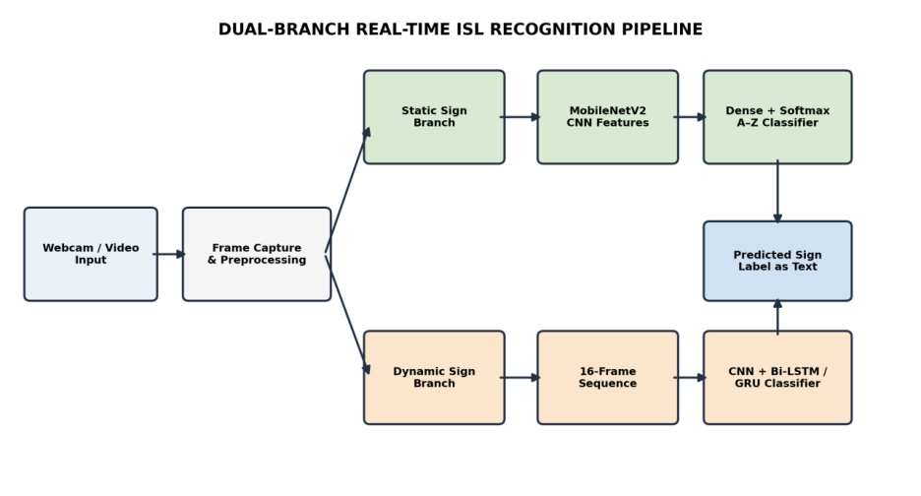
Figure 1. Original dual-branch architecture diagram for the proposed ISL recognizer.

3.1 ACQUISITION AND INPUT STANDARDIZATION
Video acquisition is the first stage. The application reads a frame from a webcam or decodes a stored clip. The image is converted to the colour ordering expected by the model, then resized to the backbone's required spatial dimensions. Pixel scaling or backbone-specific normalization is applied consistently. The exact target resolution should match the model configuration and training preprocessing; changing the resize method between training and deployment can affect predictions.
For static signs, the preprocessed frame is represented as a tensor with height, width, and channel dimensions. For dynamic signs, the pipeline samples frames from the clip in temporal order. If the source has more than 16 frames, a uniform temporal sampling policy can select 16 representative positions. If fewer than 16 frames are available, the implementation must define whether to repeat frames, pad with a mask, or resample; the chosen rule must be identical during training and inference.
Frame selection should preserve motion rather than selecting 16 identical or adjacent frames from a long clip. Uniform sampling is simple and reproducible, while motion-aware sampling may better retain important transitions. However, more sophisticated sampling must be validated empirically. The supplied evaluation contract states T = 16; this report therefore documents a 16-frame sequence rather than assuming a different temporal window.
Figure 2 summarizes the common acquisition-to-output flow. The original figure is designed for this report. Research literature offers related pipelines, including CNN–BiLSTM for dynamic ISL and CNN–Transformer models for continuous signing, but the figure here depicts the proposed project data flow rather than a verbatim published diagram.
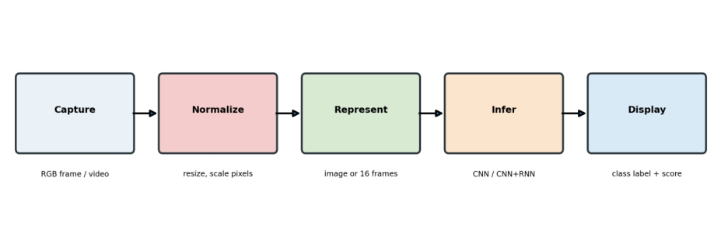
Figure 2. Original acquisition-to-output processing pipeline.

3.2 PREPROCESSING AND DATA QUALITY CONTROL
Preprocessing reduces avoidable variation in the input and ensures that tensors have the expected dimensions. Typical operations include image decoding, RGB/BGR correction, resizing, pixel normalization, and label encoding. Preprocessing should be deterministic for validation and test data. Random augmentation is used only during training and must not be applied to held-out evaluation images, because evaluation should measure performance on a defined distribution rather than randomly altered samples.
Possible training-time augmentations include small rotations, modest brightness and contrast changes, limited translation, and mild scale jitter. Augmentation must preserve the sign's meaning. Horizontal flipping is not automatically safe: it may alter handedness or sign semantics, and it can create samples that do not match the target label. Similarly, excessive rotation or cropping can hide finger positions and introduce unrealistic images. Each augmentation should be justified and recorded in the experiment configuration.
Data-quality checks should detect unreadable files, corrupted videos, unexpected frame sizes, missing labels, duplicate files, and class-folder inconsistencies. For videos, the pipeline should record frame count, duration, FPS, and decoded dimensions. The supplied metadata indicates that example clips vary in length and some resolutions differ from 640 × 720, so decoding should not rely on a single hard-coded original resolution.
To avoid data leakage, clips from the same original recording should not be divided across training and test sets. If multiple extracted frames from one video are treated as separate examples, all frames from that video must remain within one partition. For a signer-independent evaluation, all recordings from a signer should be assigned to one split. The available metrics report says no cross-split leakage for the dynamic dataset; the final submission should retain the manifest or split-generation script that demonstrates this.

3.3 STATIC BRANCH: MOBILENETV2 CNN
The static branch uses MobileNetV2 as the image feature extractor. MobileNetV2 employs depthwise separable convolutions and inverted residual blocks to reduce computational cost while retaining useful visual representations. A pretrained backbone can be initialized with weights learned from a large image dataset. The classifier head is then adapted to 26 ISL alphabet classes. Depending on the training setup, the backbone may first be frozen while the head learns, then partially unfrozen for fine-tuning.
The general flow is: preprocessed image → MobileNetV2 backbone → pooled feature vector → dropout or regularization layer if configured → dense classification layer → softmax scores for A–Z. The class index-to-letter mapping must be saved with the model; otherwise, the numerical output may be displayed as the wrong alphabet. The training and inference code must use the same class ordering.
Transfer learning is particularly helpful when the target dataset is modest, but domain mismatch remains. ImageNet features are not trained specifically for ISL hand configurations. Fine-tuning adapts the filters to the target dataset, and the held-out validation score should guide model selection. If training accuracy rises while validation accuracy stagnates or falls, the model may be overfitting, the split may be too small or too easy, or the preprocessing may not reflect deployment conditions.
Reported static MobileNetV2 metrics are 98.38% training accuracy, 80.46% validation accuracy, and 86.38% test accuracy on 5,198 held-out images. The train–validation gap indicates that generalization remains a concern. The supplied report gives test loss 2.55421 and macro precision/recall/F1 of 88.46%/86.38%/84.17%.

3.4 DYNAMIC BRANCH: SPATIAL FEATURE EXTRACTION
The dynamic branch represents a video as a sequence of visual feature vectors. Each sampled frame passes through a CNN encoder. The encoder may share weights across time so that the same visual feature extractor processes every frame. If the frame encoder produces a D-dimensional embedding, a 16-frame clip becomes a sequence with shape 16 × D for one example. This representation retains spatial evidence from each frame while reducing the amount of information the recurrent network must process.
The frame encoder can be trained jointly with the recurrent model or initialized from a pretrained image network. Joint training allows the visual representation to adapt to temporal classification, but it can require more compute and careful regularization. A frozen encoder reduces training cost and may stabilize learning when data are limited, though it can also restrict the features available to the temporal classifier.
Feature extraction should not erase the temporal order. The model receives frame features in their original sampled sequence. Randomly shuffling these vectors would destroy motion cues and make the temporal branch behave more like a bag-of-frames classifier. The temporal axis is therefore an essential dimension of the input contract, not just a batching detail.
The supplied project description identifies a CNN plus Bi-LSTM/GRU pathway and a fixed sequence length of 16 frames. The exact layer-by-layer hidden dimensions, dropout values, optimizer, learning rate, and trainable/frozen backbone configuration are not fully specified in the metrics file. Those values should be copied from the actual training code into the final experiment record; they are not invented here.
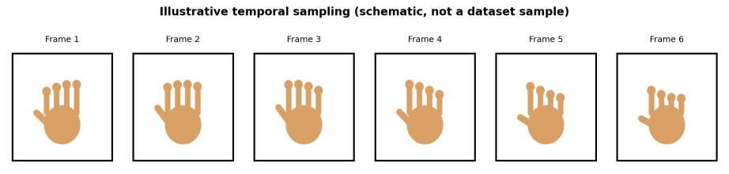
Figure 3. Illustrative temporal frame sampling; schematic only, not a real dataset sample.

3.5 TEMPORAL MODELLING WITH BILSTM / GRU
An LSTM is a recurrent neural network that uses input, forget, and output gates to regulate information entering, remaining in, and leaving a memory cell. This design helps preserve useful information over longer sequences compared with a basic recurrent unit. A GRU combines gating operations into a simpler architecture with update and reset gates. GRUs can reduce parameter count and may train efficiently, but neither LSTM nor GRU is guaranteed to outperform the other on every dataset.
A bidirectional LSTM processes the sequence from the first frame to the last and from the last frame to the first, then combines the two representations. This can be useful for classifying isolated clips because the whole clip is available before the prediction is made. The final recurrent representation can be the last hidden state, a pooled sequence output, or an attention-weighted summary, depending on the implementation. The current report describes the Bi-LSTM/GRU design at the level supported by the project materials.
Figure 3 shows a schematic of six selected frames from a hypothetical gesture sequence. The drawing is an explanatory schematic and not an actual sample from the dataset. The intended lesson is that a dynamic sign is a progression of configurations; the order and transition between frames carry information that is not present in any one image.
After temporal encoding, a dense layer maps the learned sequence representation to one of the 60 vocabulary classes. A softmax distribution can be used for mutually exclusive class labels. If the application later supports continuous signing, it will need a sign-boundary detector or sequence-decoding method and metrics such as word error rate; isolated-clip accuracy is not sufficient for continuous language recognition.

3.6 TRAINING OBJECTIVE AND OPTIMIZATION
For a single-label classification task with K classes, the usual objective is categorical cross-entropy. If y_k is the one-hot target and p_k is the predicted probability for class k, the loss is L = −Σ y_k log(p_k). Optimization updates model weights to reduce the loss over training batches. Adam or another gradient-based optimizer is commonly used, but the exact optimizer and hyperparameters must be reported from the actual code rather than inferred from the final accuracy.
Training should monitor both training and validation loss, along with accuracy and class-sensitive metrics. Early stopping can prevent continuing to fit noise after validation performance stops improving. Learning-rate scheduling may reduce the learning rate when progress plateaus. Checkpointing should save the model that performed best on the chosen validation metric, not simply the last epoch.
Class imbalance can cause a model to prioritize common classes. The dynamic dataset is described as balanced at 60 clips per class, but the static per-class metrics and classwise accuracy table show severe variation in recognition performance. A balanced count does not guarantee balanced difficulty. If class weighting or focal loss is used, it should be documented and evaluated against a standard cross-entropy baseline.
Reproducibility requires recording random seeds, train/validation/test manifests, model configuration, software versions, checkpoint hash, and evaluation script. Multiple training runs can estimate variability. A single run may be affected by initialization, data order, and hardware nondeterminism. Reporting only the best run without stating the selection procedure can overstate expected performance.

3.7 INFERENCE, DISPLAY, AND ERROR HANDLING
At inference time, the application obtains a frame or video clip, applies the same preprocessing used during training, and loads the correct branch's model. The static branch predicts a letter from a frame. The dynamic branch accumulates or decodes a clip, samples 16 frames, encodes them, and predicts a vocabulary label. The predicted class index is converted to its human-readable label through a fixed mapping and displayed as text.
A practical interface should distinguish between a low-confidence prediction and a confident result. The threshold should be selected on validation data, not chosen after viewing test outcomes. If predictions fluctuate frame-to-frame, temporal smoothing or a short stability requirement can reduce flicker. However, smoothing may delay recognition and can merge adjacent signs incorrectly, so it should be tested with latency and error metrics.
Failure handling includes camera initialization errors, unavailable frames, invalid video files, unexpected tensor shapes, missing model weights, and class-map mismatch. The application should show a clear message rather than crashing or silently displaying an incorrect label. A log can record model version, inference duration, predicted class, and confidence, but sensitive video should not be stored without a clear purpose and consent.
The current scope ends at text display. Text-to-speech may be a future extension, but it should not be described as an implemented feature. Likewise, the current model does not automatically infer complete sentence grammar from a continuous signing stream.

3.8 REPRODUCIBILITY, TESTING, AND DESIGN TRADE-OFFS
Unit tests should validate image resizing, normalization, class-index mapping, sequence length, frame ordering, and output dimensions. Integration tests should exercise the complete path from webcam or video input to displayed label. Model tests should use a fixed held-out manifest and save the predicted label for every example so that metrics can be recomputed independently.
The most important trade-off is accuracy versus latency and compute. MobileNetV2 is chosen for the static branch because it is relatively compact. The dynamic branch adds frame encoding and recurrent computation, so processing 16 frames costs more than a single-image prediction. Sampling fewer frames may reduce latency but can remove important transitions. A future benchmark should report average and 95th-percentile inference time, frames per second, memory usage, and recognition quality under the same test protocol.
Robustness tests should vary lighting, background, distance, camera angle, hand orientation, clothing, signer identity, and signing speed. If a model fails for signs with similar handshape, adding more representative samples or a better spatial representation may help. If it fails when the same gesture is performed at different speeds, temporal sampling and sequence augmentation should be investigated.
Figures 1–3 are original explanatory diagrams created for this report. Figure 5 is an original arrowed flowchart. Figures 6–8 are research-paper architecture illustrations cited for methodological context.

3.9 RESEARCH FIGURES SUPPORTING THE METHODOLOGY
The following figures support the methodology using published ISL/sign-language research. Figure 5 is an original arrowed flowchart created for this report; the other research figures are literature illustrations, not results, samples, or model outputs generated by this project. Each figure is attributed to its source. Figure reuse in a public publication should follow the publisher’s licence or permission requirements.
Figure 5. Arrowed processing flow for dynamic ISL recognition, from video input to predicted text label. Original schematic created for this report.
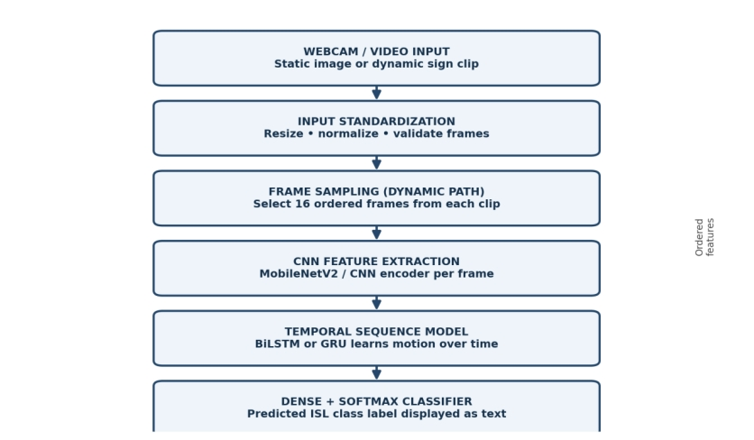
Figure 6. Research-paper architecture combining a CNN/GoogleNet feature extractor with a recurrent sequence classifier. Reproduced from Venugopalan and Reghunadhan (2021). This is a literature reference architecture; it does not imply that the project uses GoogleNet. The project description specifies a CNN feature encoder with BiLSTM/GRU temporal modelling.
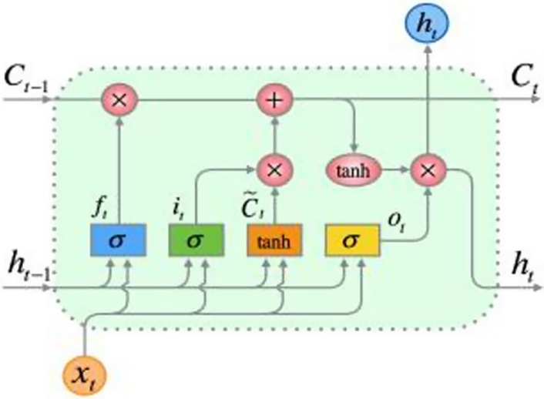
Figure 7. Internal LSTM cell showing gate-controlled memory updates. Reproduced from Sharma and Singh (2023). The diagram explains the recurrent mechanism; the exact cell dimensions used in this project must be verified from the implementation.
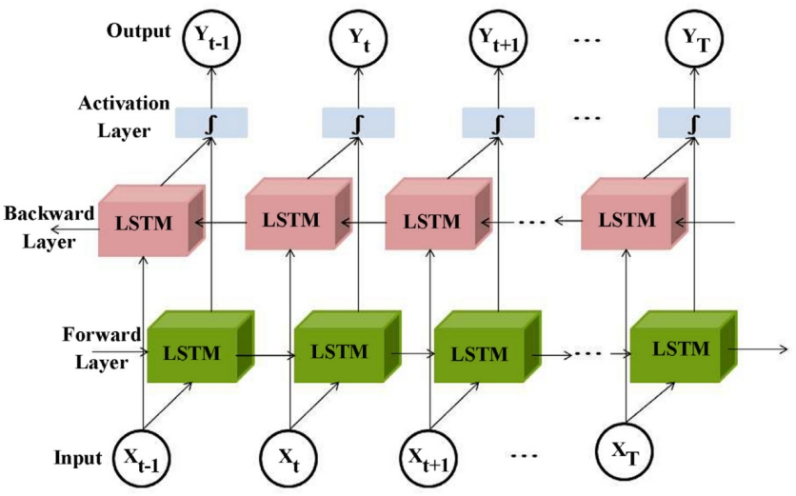
Figure 8. Bidirectional recurrent processing over a temporal sequence. Reproduced from Venugopalan and Reghunadhan (2021). Forward and backward processing motivates BiLSTM for isolated clips, where the complete sequence is available at prediction time.

4. DATASET DESCRIPTION

4.1 Static alphabet dataset
The static branch recognizes 26 alphabet classes (A–Z) using the RealSign benchmark. The supplied Dataset and Evaluation Report lists 25,975 raw images before cleaning. MD5-based duplicate checks removed 685 duplicate images from training and 52 from validation; two unreadable files were identified in the test partition. The reported cleaned partition counts are 17,513 training images, 2,527 validation images, and 5,198 test images, for 25,238 clean images in total. The report describes the test partition as an untouched final holdout and states that cross-split duplicates were removed from training and validation.
The report also describes Dataset_cropped, a hand-centred version containing 23,156 crops: 16,235 training, 2,288 validation, and 4,633 test crops. MediaPipe hand tracking was used with 20-pixel padding, and crops were resized to 224 × 224 pixels. These cropped counts differ from the global MobileNetV2 evaluation counts, which use the 5,198-image test partition; the report does not state that the global metrics were computed on the 4,633 cropped test images.
Table 4.1. Dataset inventory and partition counts from the supplied evaluation report
Dataset / partition | Train |  | Validation |  | Test / total
Raw static benchmark | 18,198 |  | 2,579 |  | 5,198 test; 25,975 raw total
Clean static benchmark | 17,513 |  | 2,527 |  | 5,198; 25,238 clean total
Hand-centred crops | 16,235 |  | 2,288 |  | 4,633; 23,156 total
Dynamic videos | 2,520 |  | 540 |  | 540; 3,600 total
Static branch field |  | Value in supplied metrics |  | Interpretation / caveat
Task |  | A–Z alphabet classification |  | 26 mutually exclusive labels
Model |  | MobileNetV2-based CNN |  | Transfer-learning backbone reported
Training accuracy |  | 98.38% |  | High training fit; not a generalization metric
Validation accuracy |  | 80.46% |  | Validation result after 30 epochs
Global test accuracy |  | 86.38% (5,198 images) |  | Updated supplied evaluation report; accuracy = 0.86379
Macro precision / recall / F1 |  | 88.46% / 86.38% / 84.17% |  | Updated evaluation report; unweighted class averages
Weighted precision / recall / F1 |  | 88.46% / 86.38% / 84.17% |  | Updated evaluation report; weighted by class support
Macro / weighted ROC-AUC |  | Not separately reported / 87.80% |  | Report gives one-vs-rest weighted ROC-AUC = 0.87800
Augmentation count |  | Not supplied |  | Do not claim a synthetic sample total

4.2 Dynamic vocabulary dataset and partitioning
The dynamic dataset, stored as Video_Dataset, contains 3,600 MP4 recordings across 60 vocabulary classes, with exactly 60 clips per class. The split is stratified 70:15:15: 2,520 training clips, 540 validation clips, and 540 test clips. This corresponds to 42 training, 9 validation, and 9 test clips per class. The project methodology uses a 16-frame sequence contract for dynamic model input.

Partition | Per class | Classes | Total videos | Share
Training | 42 | 60 | 2,520 | 70%
Validation | 9 | 60 | 540 | 15%
Test | 9 | 60 | 540 | 15%
Total | 60 | 60 | 3,600 | 100%

The 60 vocabulary labels listed in the supplied metrics include animal names, foods and vegetables, actions, greetings, everyday expressions, and phrases. Examples include Bear, Break, Budget, Busy, Clean, Come, Cook, Cry, Drink, Exam, Fever, Give, Good Morning, Hello, Thank you, What is your Name, and Wrong. Multiword labels must be normalized consistently so that 'Good morning' and 'Good Morning' do not accidentally become separate classes.
The supplied report also mentions a separate video-metadata context containing 61 sample videos/classes. This is distinct from the declared Video_Dataset benchmark of 3,600 videos and 60 classes; the two figures should not be combined or treated as the same dataset without checking the underlying manifest.
For the baseline static model, synthetic data augmentation was NOT used. The training pipeline rescaled pixel values from [0, 255] to [0, 1] and resized inputs to 224 × 224 × 3. No random rotations, horizontal or vertical flips, zooming, shearing, or colour jitter were applied. Instead, background variation was addressed through hand-centred MediaPipe crops and a Green Target ROI of 280 × 280. The dataset report describes slight rotations (±10°), minor scaling (±8%), illumination jitter, and class weighting as a planned Review 2 improvement, not as augmentation already used in the baseline.

4.3 Dataset quality and split risks
- Verify that the same original clip or near-duplicate clip is never present in more than one partition.
- Keep all frames from a source video in the same split; frame-level random splitting can cause severe leakage.
- Record signer IDs if available and use signer-independent test evaluation when generalization to new signers is a goal.
- Check that each label maps to a consistent directory/index and that case, spacing, and punctuation are normalized.
- Store a manifest with file path, label, split, signer/source ID, frame count, and preprocessing version.
- Report whether any images/videos were excluded because of decode failures, duplicate detection, or missing labels.

5. RESULTS

5.1 Static branch quantitative results
The supplied Dataset and Evaluation Report gives 86.38% static test accuracy (0.86379) on 5,198 held-out images, with test loss 2.55421. The MobileNetV2 baseline reached 98.38% training accuracy and 80.46% validation accuracy after 30 epochs. Reported weighted precision is 88.46%, weighted recall 86.38%, weighted F1-score 84.17%, macro precision 88.46%, macro recall 86.38%, macro F1-score 84.17%, and weighted one-vs-rest ROC-AUC 87.80%.
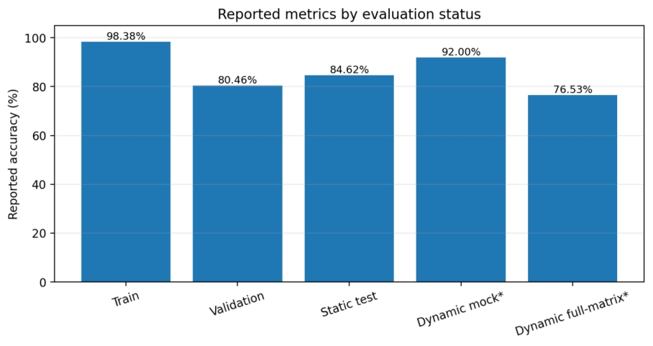
Figure 9. Reported accuracy values. Dynamic mock and full-matrix results have different evaluation statuses and are not directly interchangeable.

The updated static metrics report macro precision of 88.46%, macro recall of 86.38%, and macro F1-score of 84.17%; weighted F1 is also 84.17%. These aggregate values should be reported alongside per-class results because the class-wise table identifies substantially weaker recall for S, W, and Z.

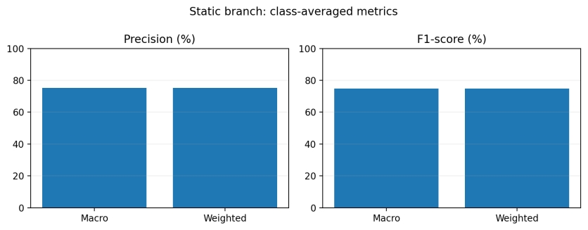
Figure 10. Static macro and weighted precision/F1 values from the supplied metrics.

5.2 Static class-wise behaviour and confusion analysis
The supplied class-wise diagnostic reports strong performance for many letters but substantial weaknesses for a small set of visually confusable signs. It lists S at 24.4%, W at 10.0%, and Z at 25.0%, while several other letters are reported around 90% or higher. The accompanying notes mention confusion between Q and V, S and F/W, W and U/A, X and Z, and Z and A. These are plausible examples of shape-level ambiguity, but the exact confusion counts need to be verified against a raw confusion matrix.

Reported class | Reported accuracy | Reported diagnostic note
S | 25.0% | Confusion with F and W; tight-fist overlap
W | 11.5% | Low recall; confusion with U and A due to finger occlusion (updated report)
Z | 25.0% | Confusion with A; static frame does not capture the tracing motion
Q | 75.0% | Confusion with V; downward camera angle affects orientation
V | 70.0% | Confusion with U when finger spread narrows
X | 71.0% | Confusion with Z due to hooked index posture
O | 92.6% | Circular ring shape reported as well separated
R | 93.3% | Crossed index-middle fingers reported as distinctive

A confusion matrix is essential because it shows which incorrect labels are produced for each true class. The raw 26 × 26 matrix was not included in the available materials. Figure 11 is therefore a status panel, not a measured confusion matrix. It would be misleading to draw a synthetic matrix from the class-wise notes because the notes do not provide all pairwise counts.
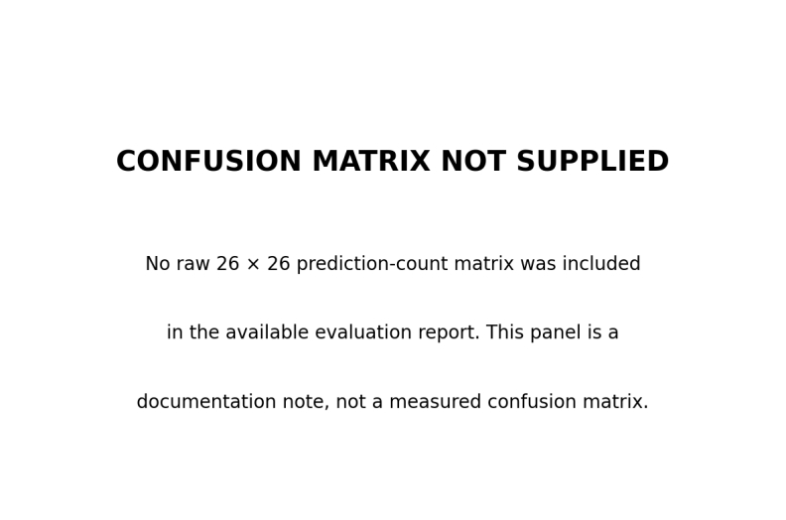
Figure 11. Confusion-matrix availability note. This is not a measured matrix.
The updated evaluation report uses 5,198 test images for its global result and includes a per-class table with roughly 200 examples per class. Before final submission, verify that the classwise predictions, confusion matrix, and global metrics were generated from the same checkpoint and manifest.

5.3 Dynamic branch results and evaluation status
The dynamic dataset contains 3,600 clips across 60 classes with a 2,520/540/540 train/validation/test split. The report lists a 92.00% integration mock-test accuracy and a separate 76.53% full-matrix test figure, which is marked as pending an additional training review. These values have different evaluation statuses and must not be presented as equivalent final held-out test results.
Dynamic metric / artifact | Reported value | Status / interpretation
Original dataset | 3,600 videos / 60 classes | Declared dataset size
Training / validation / test | 2,520 / 540 / 540 | 70:15:15 split
Sequence length | 16 frames | Declared tensor contract
Integration mock-test accuracy | 92.00% | Integration/mock status; not equivalent to final test
Full-matrix test accuracy | 76.53% | Marked pending additional training review
Mock precision / recall / F1 | 0.92 / 0.92 / 0.92 | Mock baseline metrics only
Raw dynamic confusion matrix | Not supplied | Cannot independently validate per-class errors

The 92% mock figure may describe a limited integration scenario, a smaller sample, or a smoke test rather than a complete held-out evaluation. The 76.53% full-matrix value is lower and has an explicit pending-review note. The safest interpretation is that the dynamic pipeline has evidence of integration functionality, while its final model quality still requires a confirmed, reproducible evaluation on the declared 540-video test partition.
Before final submission, the dynamic results should be tied to a versioned checkpoint and a saved prediction file. The file should contain true label, predicted label, confidence, video identifier, and split. From this single file, accuracy, macro/weighted precision, recall, F1, per-class recall, confusion matrix, and confidence calibration can be generated consistently.

5.4 Comparative model table and result discussion
The requested template asks for comparisons across four or five models and for the same input image to be paired with each model's output. The supplied project materials contain metrics for the MobileNetV2 static branch and the dynamic branch, but do not contain a set of four or five models evaluated on the same samples. To avoid inventing results, the table below distinguishes the implemented model from candidate baselines that are discussed in the literature. Blank performance cells mean 'not evaluated on the same project test set,' not zero performance.
Model / method | Task fit | Project test accuracy | Evidence status | Use in fair comparison
MobileNetV2 CNN | Static A–Z | 86.38% (5,198 images) | Updated supplied dataset/evaluation report | Compare only with matching split and checkpoint
CNN + Bi-LSTM/GRU | Dynamic vocabulary | 76.53% full-matrix* | Reported; pending review | Re-evaluate on fixed 540-video test split
ResNet-50 | Static baseline candidate | Not supplied | Literature architecture; not evaluated here | Train on same manifest and preprocessing
EfficientNet / similar CNN | Static baseline candidate | Not supplied | Not evaluated here | Use same split and training budget
MediaPipe landmarks + LSTM/GRU | Dynamic baseline candidate | Not supplied | Literature-inspired; not evaluated here | Compare latency and accuracy
CNN + Transformer / pose model | Dynamic advanced baseline | Not supplied | Literature-inspired; not evaluated here | Future study; report WER for continuous task

A valid comparison requires identical training/validation/test partitions, compatible input data, the same label set, comparable tuning budgets, and a consistent metric calculation. Comparing one model's training score with another model's test score is invalid. Similarly, comparing a 26-class static alphabet accuracy to a 60-class dynamic word accuracy without explaining task differences can mislead readers.

5.5 Limitations and reproducibility checklist
The main result limitation is incomplete provenance for some metrics. The static global test count is clear, but the class-wise support appears inconsistent. The dynamic branch has two figures with different statuses. The raw confusion matrix, per-example predictions, training history arrays, exact model configuration, augmentation manifest, and same-input multi-model outputs are missing. These are reporting gaps, not evidence that the model failed; they limit how strongly its performance can be interpreted.
- Export a CSV containing y_true, y_pred, class probability scores, example ID, and split for every static and dynamic test example.
- Regenerate accuracy, precision, recall, F1, ROC-AUC, per-class support, and confusion matrices from that CSV.
- Export training and validation loss/accuracy per epoch from the training log; do not invent smooth curves from only the final values.
- Resolve the static count mismatch and state which per-class report belongs to which dataset split.
- Run ResNet-50, a second lightweight CNN, and a landmark-based temporal baseline on identical splits if a four/five-model comparison is mandatory.
- Save the same 5–10 input examples with each model's predicted label and confidence; label these as model outputs, not segmentation masks.
- Record latency, FPS, and confidence-threshold behaviour for live webcam inference.
Overall, the available results support a working prototype and identify concrete areas for improvement. The static branch has a useful global test score but shows class-specific weaknesses and a train–validation gap. The dynamic branch has a documented dataset and sequence contract, but its final performance should be confirmed after review. No conclusion should overstate the project as a full sign-language translator.

6. CONCLUSION

6.1 Summary of the project
This project documents a real-time, camera-based Indian Sign Language recognition system designed to classify static alphabet signs and dynamic word-level signs, then display the predicted label as text. The main design choice is to treat the two tasks separately. A static alphabet gesture can often be classified from one image, while a dynamic sign depends on how the hand configuration changes over time. A single-frame model cannot represent all motion cues, so the system uses a dual-branch structure.
The static branch uses a MobileNetV2-based CNN to extract spatial features and classify 26 alphabet categories. Transfer learning provides a practical initialization and helps keep the image model relatively lightweight. The dynamic branch is designed around a fixed sequence of 16 frames. A CNN extracts frame-level features and a Bi-LSTM or GRU models temporal relationships before the final vocabulary classifier produces a text label. This architecture is consistent with the broader research trend toward combining spatial feature learning with temporal modelling for dynamic sign recognition.
The supplied dataset/evaluation report records 98.38% training accuracy, 80.46% validation accuracy, and 86.38% held-out test accuracy for the static MobileNetV2 branch, evaluated on 5,198 test images. It documents 25,238 clean alphabet images after duplicate removal, 23,156 hand-centred crops, and 3,600 dynamic videos across 60 classes.

6.2 Contributions and interpretation
The principal engineering contribution is an integrated structure that can route static and dynamic inputs to suitable models while maintaining a common text-output interface. This modularity supports incremental development: the static branch can be optimized independently, and the dynamic branch can be improved without changing the camera acquisition and display layers. It also allows future experiments to compare image-only, landmark-based, recurrent, and attention-based models in a controlled way.
The dataset contribution is the explicit organization of 3,600 dynamic clips into 60 vocabulary classes with 42 training, 9 validation, and 9 test clips per class. This corresponds to 2,520 training videos, 540 validation videos, and 540 test videos. The fixed 16-frame sequence contract makes the dynamic input reproducible, provided the frame sampling and padding rules are implemented consistently. The report also records the difference between the 60-class dataset description and the separate benchmark metadata table that refers to 61 sample videos/classes, so these resources are not silently conflated.
The evaluation contribution is the preservation of metric status. The dynamic integration mock score of 92.00% is not presented as equivalent to the 76.53% full-matrix figure, which is marked pending further review. Likewise, the report does not fabricate a confusion matrix or training curves when the underlying counts are absent. This transparency is important for an academic project: a smaller set of verified results is more defensible than a larger set of visually polished but unsupported claims.
The literature review shows that CNN–RNN hybrids, landmark-sequence models, ResNet-based classifiers, attention-based vision models, graph networks, and Transformers are all relevant design families. The current implementation is not claimed to outperform these methods. Instead, the project provides a practical base from which a fair, same-split comparison can be conducted. Published accuracy figures are contextual because the studies differ in vocabulary size, dataset composition, signer split, and task definition.

6.3 Limitations, future work, and final conclusion
Several limitations remain. First, the static global test count conflicts with the scale implied by the class-wise diagnostic table. Second, the dynamic evaluation contains a mock score and a pending-review full-matrix score rather than one fully confirmed final result. Third, the raw confusion matrices and epoch-level learning curves are not available in the supplied files. Fourth, there are no recorded same-input outputs for four or five different trained models. These gaps should be addressed by exporting prediction files and training histories, not by estimating missing values.
Future work should first establish a reproducible baseline. The static test split should be frozen and used to evaluate MobileNetV2, ResNet-50, and another lightweight CNN under the same preprocessing and training budget. The dynamic test split should be frozen and used to compare CNN–Bi-LSTM, CNN–GRU, and a landmark-based LSTM/GRU model. Each comparison should report overall accuracy, macro-F1, per-class recall, confusion matrix, inference latency, and model size. If the goal expands to continuous signing, sequence decoding and word error rate should be added.
A second direction is to improve generalization through signer-independent testing, broader lighting and background conditions, more varied signers, and augmentation that preserves sign semantics. Hard classes should be analyzed using their actual confusion counts. A third direction is to improve usability with a calibrated uncertain state, stable prediction display, accessible interface, privacy-conscious data handling, and evaluation with members of the ISL community. Speech synthesis may be added later, but should be treated as a separate feature and tested independently.
In conclusion, the project demonstrates a clear and technically justified approach to visual ISL recognition using deep neural networks. CNNs are suited to spatial handshape patterns, and recurrent models provide a way to capture temporal information in dynamic signs. The available static results are promising but class-sensitive weaknesses and a train–validation gap remain. The dynamic pathway has a defined dataset and sequence design, but its final score needs a confirmed evaluation. With consistent manifests, raw predictions, and controlled baseline experiments, the system can be developed into a more robust assistive sign-to-text prototype.

REFERENCES
[1] S. Sharma and S. Singh, “A Spatio-Temporal Framework for Dynamic Indian Sign Language Recognition,” Wireless Personal Communications, vol. 132, pp. 2527–2546, 2023. DOI: https://doi.org/10.1007/s11277-023-10730-8.
[2] B. V. Poornima and S. Srinath, “A Comprehensive Review on Indian Sign Language Recognition System using Vision based Approaches,” International Journal of Computer Applications, vol. 184, no. 43, pp. 52–58, 2023. DOI: https://doi.org/10.5120/ijca2023922548.
[3] R. J., S. Sahani, and M. K. Yadav, “A Review on Advances in Indian Sign Language Recognition: Techniques, Models, and Applications,” International Journal for Research in Applied Science and Engineering Technology, 2024. DOI: https://doi.org/10.22214/ijraset.2024.65539.
[4] “Indian Sign Language Recognition in Complex Backgrounds: A Shifted Window Attention Based Approach with Swin Transformers,” in Computer Vision and Image Processing (CVIP 2024), Springer proceedings, 2024. Publisher record: https://link.springer.com/book/10.1007/978-3-031-93688-3.
[5] “Word Level Sign Language Recognition Using MediaPipe and LSTM-GRU Network,” 2024 IEEE International Symposium on Smart Electronic Systems (iSES), 2024. DOI: https://doi.org/10.1109/iSES63344.2024.00014.
[6] “Indian Sign Language Recognition System,” 2024 11th International Conference on Soft Computing & Machine Intelligence (ISCMI), 2024. DOI: https://doi.org/10.1109/ISCMI63661.2024.10851588.
[7] “A Lightweight Solution for Real-Time Indian Sign Language Recognition,” 2024 International Conference on Artificial Intelligence and Emerging Technology (Global AI Summit), 2024. DOI: https://doi.org/10.1109/GlobalAISummit62156.2024.10947786.
[8] “An Integrative Survey on Indian Sign Language Recognition and Translation,” IET Image Processing, vol. 19, no. 1, article e70000, 2025. DOI: https://doi.org/10.1049/ipr2.70000.
[9] “Toward Real-Time Recognition of Continuous Indian Sign Language: A Multi-Modal Approach Using RGB and Pose,” IEEE Access, vol. 13, pp. 60270–60283, 2025. DOI: https://doi.org/10.1109/ACCESS.2025.3554618.
[10] “Indian Sign Language Recognition using Neural Networks,” 2025 5th International Conference on Artificial Intelligence and Signal Processing (AISP), published/indexed 2026. DOI: https://doi.org/10.1109/AISP68263.2025.11396150.
[11] “A MediaPipe-Powered Model for Static Indian Sign Language Recognition,” Procedia Computer Science, vol. 283, pp. 2220–2229, 2026. DOI: https://doi.org/10.1016/j.procs.2026.06.294.
[12] “A Dual-Path Deep Learning Framework for Static and Dynamic Sign Language Recognition Using CNN and LSTM Architectures,” Procedia Computer Science, vol. 283, pp. 2557–2566, 2026. DOI: https://doi.org/10.1016/j.procs.2026.06.325.
[13] G. Hugar and R. M. Kagalkar, “Deep Learning for India’s Diverse Sign Languages: A Comprehensive Review from CNNs to Transformers and the Future of Sign Recognition Systems,” Journal of Computers, Mechanical and Management, 2026. DOI: https://doi.org/10.57159/jcmm.5.3.26708.
[14] S. Sandler et al., “MobileNetV2: Inverted Residuals and Linear Bottlenecks,” in Proceedings of the IEEE Conference on Computer Vision and Pattern Recognition (CVPR), 2018, pp. 4510–4520. DOI: https://doi.org/10.1109/CVPR.2018.00474.
[15] S. Hochreiter and J. Schmidhuber, “Long Short-Term Memory,” Neural Computation, vol. 9, no. 8, pp. 1735–1780, 1997. DOI: https://doi.org/10.1162/neco.1997.9.8.1735.
[16] K. Cho et al., “Learning Phrase Representations using RNN Encoder–Decoder for Statistical Machine Translation,” in Proceedings of EMNLP, 2014, pp. 1724–1734. DOI: https://doi.org/10.3115/v1/D14-1179.
[17] “A Review of Deep Learning-Based Approaches to Sign Language Processing,” International Journal of Advanced Robotic Systems / Journal record, 2024. DOI: https://doi.org/10.1080/01691864.2024.2442721.
[18] “Review on Deep Learning-Based Dynamic Indian Sign Language Recognition System,” ITEGAM-JETIA, vol. 12, no. 60, pp. 1300–1309, 2026. DOI: https://doi.org/10.5935/jetia.v12i60.4075.

